ANNUAL REPORT 2017-18
We have been pleased to welcome GOSH, Gastro-Oesophageal Support and Help, Bristol, as the nineteenth organisation supporting our campaign to promote the earlier diagnosis and prevention of oesophageal adenocarcinoma through raising awareness of the links between persistent heartburn, Barrett’s Oesophagus and adenocarcinoma. During the year CORE charity changed its name to Guts UK.
We again promoted the February Oesophageal Cancer Awareness Month, and were fortunate enough to have sufficient funding to display bus advertisements in the Birmingham area.
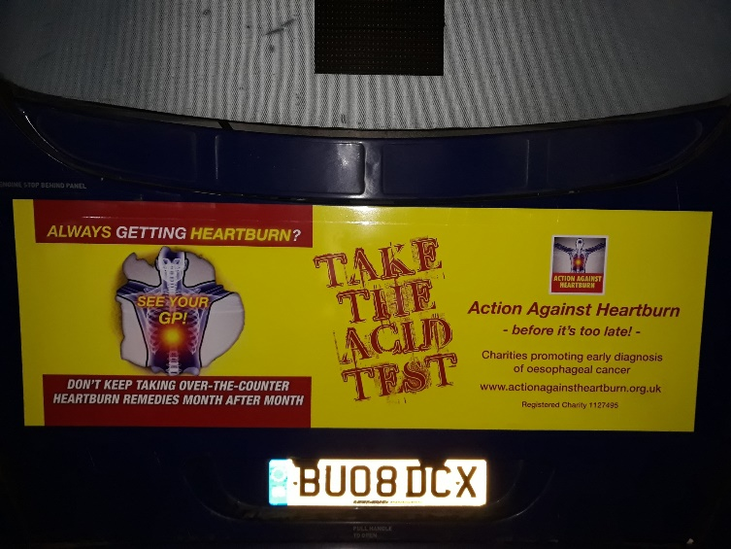
We also distributed car window stickers to promote our message:
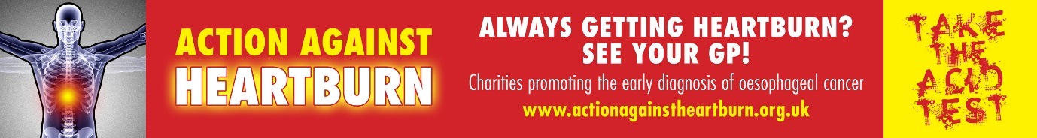

As well as distributing leaflets, posters and other material through our network of volunteers with the prime target of pharmacies dealing with regular customers of over-the-counter heartburn medication and GP surgeries, we achieved some good coverage from local newspapers. The patients’ group from Queen Elizabeth hospital Birmingham (linked with the Oesophageal Patients Association - OPA) ran a number of awareness events at supermarkets, at the hospital, and so on.
The OPA distributed around 100 packages to support the cause under their RefLux initiative including football crowd-related activities. A number of our supporting charities (eg Barretts Wessex) undertook local initiatives during the month. The message reached Orkney, where our volunteer achieved excellent coverage, and this included a poster displayed in the Scottish Parliament building. The campaign was supported by social media and internet advertising.
We were disappointed that Public Health England’s (PHE) regional Be Clear on Cancer campaign about abdominal symptoms, which would have potentially made an impact against oesophageal cancer, did not take place. Nor has there been any sign of PHE repeating their oesophago-gastric campaign which did so much to raise awareness of the public health issue of persistent heartburn.
Oesophageal cancer continues to represent a major cancer concern. About 8,200 are diagnosed with it in the UK each year, and around 7,600 die from it. The UK is reported as having the highest incidence of oesophageal adenocarcinoma in the world. This form of the disease represents about 70% of UK cases. It is the seventh most common cause of cancer death in the UK, and the 5-year survival rate is only 15%.
Because of this high level of mortality, we have continued as founder members of the Less Survivable Cancers Taskforce. The origins of the Taskforce lay in the groups of cancers identified (Hannah McConnell et al. BMJ Open 2017;7:e016797) as having research and treatment needs dictated by their patients’ longer term, intermediate and shorter term survival. As progress has been made against other cancers over the past decades, it is now time to concentrate research and other resources on where they will make most impact on survival.

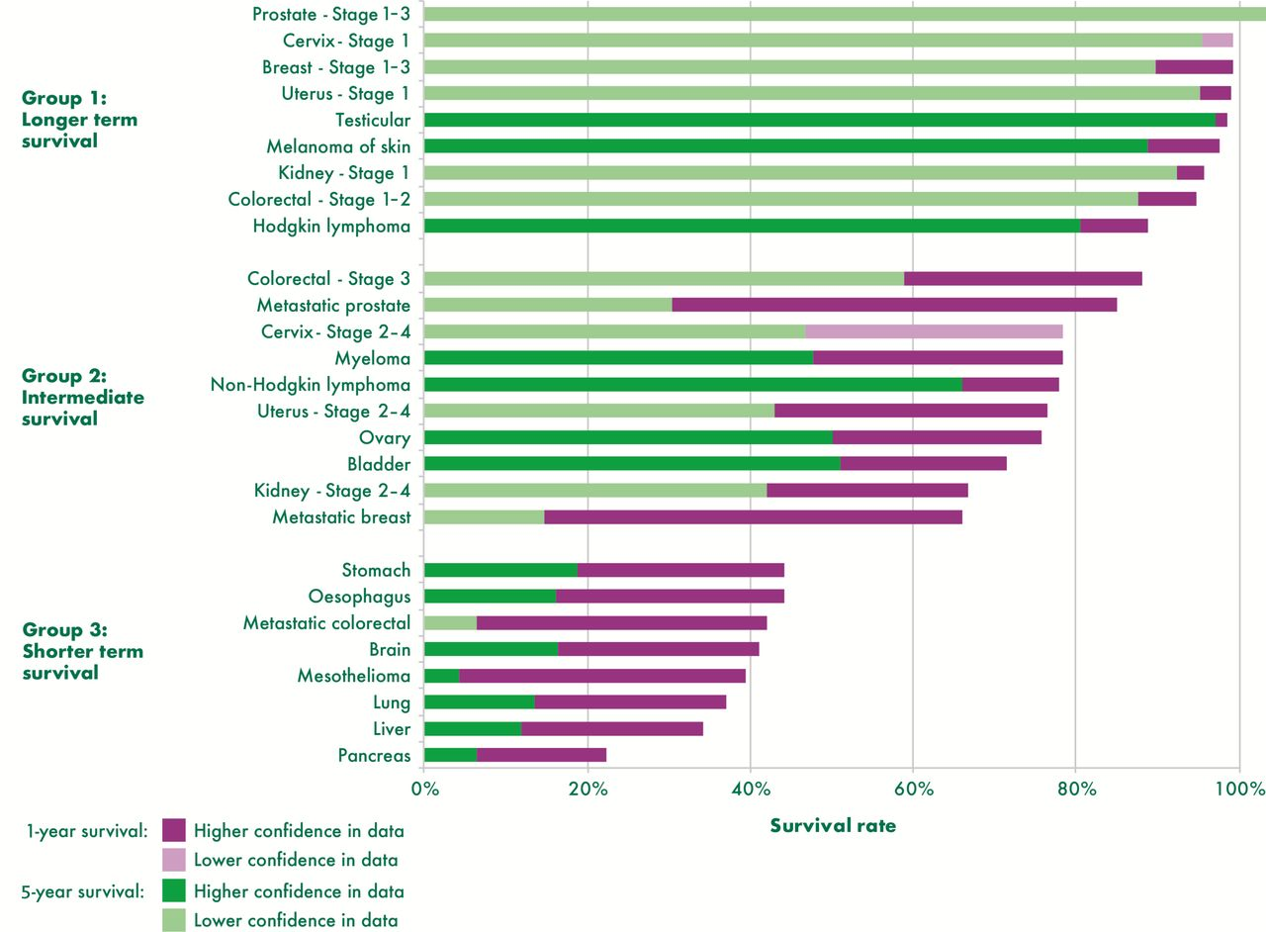

We welcome the Prime Minister’s October 2018 announcement of an initiative to concentrate on earlier diagnosis for cancer, and hope that the ‘top ten’ cancers marked for attention will be based on those cancers with the heaviest mortality. We also envisage that in due course, and subject to trial results, screening will be possible from GP surgeries with devices like Cytosponge that is aimed at detecting Barrett’s Oesophagus.
We continue to support the case for better labelling of over-the-counter heartburn medication, and are in the process of seeking support from the Medicines and Healthcare Products Regulatory Authority.
Finally we are grateful to the Trustees of Barretts Oesophagus UK, registered charity 1127495, under whose jurisdiction Action Against Heartburn operates.

Alan Moss, Chairman
7 Winnipeg Drive, Green Street Green, Orpington, Kent, BR6 6NW
Email: alanmoss32@gmail.com Tel: 01689 858677

